|  |
| --- |
| AFYA BORA CONSORTIUM GLOBAL HEALTH LEADERSHIP FELLOWSHIP PROGRAM |
| PROJECT MANAGEMENT MODULE |
|  |

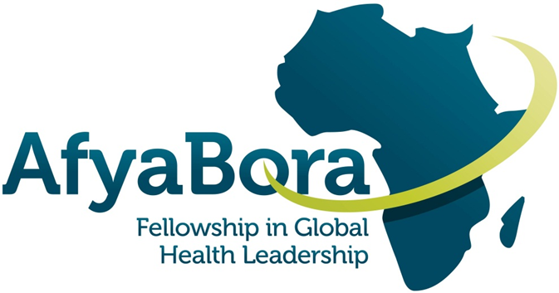

Participant and Instructor Guide

|  |
| --- |
| Instructors: Susan Chapman and Onesmus Gachuno |

**AFYA BORA CONSORTIUM**

**PROJECT MANAGEMENT MODULE**

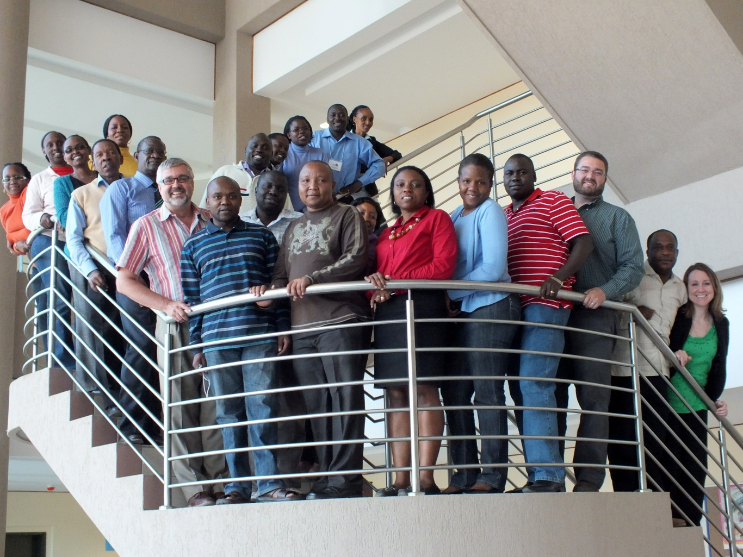

**Guide for Fellows and Instructors**

**Contact Us:**

|  |  |
| --- | --- |
| Susan Chapman, PhD, RN  Associate Professor | Department of Social & Behavioral Sciences  School of Nursing  University of California, San Francisco  San Francisco, CA 94118  Email: *Susan.Chapman@ucsf.edu* |
| Onesmus Gachuno, MBChB, MMed  Senior Lecturer | Department of Obstetrics and Gynaecology  College of Health Sciences  University of Nairobi  Nairobi, Kenya  E-mail: *owgachuno@yahoo.com* |

Table of Contents

Course Overview 3

Goals of the Module 3

Learning Objectives: 4

Teaching Methods: 4

Module Schedule 5

Project Management Exercises 8

Appendices 11

Appendix 1: Small Group Exercises 11

Exercise 1: Project Set-Up 11

Exercise 2: Connecting to Mission and Vision 12

Exercise 3: Draft Your Project Plan 13

Exercise 4: Review your project objectives and outcomes 17

Case Study: Assisted Partner Notification 34

Background 34

List of abbreviations and acronyms 39

NOTES 40

# Course Overview

A critical component of implementing a research study or project is Project Management. A Project Manager is responsible for a multitude of duties/tasks, including preparing and managing grants and project budgets, complying with government regulations, preparing project reports and regulatory submissions, creating data collection forms, managing project data, managing human resources, conducting regular project team meetings, preparing and managing the project timeline, and producing the project deliverables. Sometimes a project manager may need to focus on improving processes when administrative, clinical, or research problems occur. These project improvements may be addressed by short cycle improvement techniques such as a Plan, Do, Study, Act (PDSA) cycle for process improvement. Many professionals who have taken on the role as project manager know all too well the difficulties of learning all these tasks “on-the job”. This module focuses on the skill set required for effective project management.

# Goals of the Module

Project management is an essential skill for success in any organization. In today’s complex health care delivery and research environment a project-based team approach is becoming common and necessary. In order to implement successful projects in this environment, one must pay great attention to planning. This includes developing and managing timelines, budgets, scope of work, risks, unforeseen problems, clients, stakeholders, and fellow team members.

Effective project management ensures cost effective use of valuable resources such as people and funds.

The skill set required for effective project management is not necessarily the same set of skills needed for success as a clinician or researcher. Many clinical staff in health care have not been taught project management skills. Project management has too often been seen as an unnecessary add-on or something that just will happen automatically.

This workshop will assist you to develop the range of skills appropriate for effective project management in a health care or research setting.

To help each Fellow understand the goals of this module and get the most from it, we have created a self-assessment questionnaire (Appendix 1) to be completed at 3 times: (1) at the beginning of the module; (2) at the end of the module; and (3) at the completion of the whole Fellowship. Please complete the questionnaire and submit it by the end of the first day of the module.

|  |
| --- |
| Fellows will be given 15 minutes to complete the questionnaire at the end of the introductory lecture on the first day of the module. This is an anonymous questionnaire and will NOT carry their name. The questionnaire will be administered by a representative of I-TECH. |

# Learning Objectives:

The objective of this module is to provide fellows with the foundational skills necessary to be successful in Project Management. At the end of the course fellows should be able to:

1. Explain (Understand) what is meant by the meaning of “project” and provide examples of different types of projects, including research, administrative, clinical service, regulatory, and process improvement.
2. Describe the concepts used in project management, project planning and development of project plan, preparing to federal and international regulations, budgeting and financial management, human resources management, data management, development and monitoring of project timeline and deliverables, interim and final reporting, and internal evaluation.
3. Prepare a sample project implementation plan including objectives and deliverables, budget, timeline, and staffing plan.
4. Develop a process improvement plan including steps for a small test of change (**P**lan, **D**o, **S**tudy, **A**ct)
5. Demonstrate skills in planning, implementation and monitoring all aspects of research projects including administrative, financial, personnel, data management, and evaluation.
6. Define federal and international regulations in research coordination and project management

# Teaching Methods:

The course is taught in 4 complementary types of sessions: 1) Lecture and Discussion, 2) Small Group Work, 3) Fieldwork and Discussion, 4) Fellow Presentations.

There will be two types of Small Group Work:

* There will be three 1-hour sessions during which fellows will have the opportunity to design a project together which will include the major elements required for effective project management of a successful project.
* There will be four 1-hour sessions for fellows to complete a total of 11 exercises on project management

All group work will be presented by fellows during the course of the week and discussed with all fellows in the class.

# Module Schedule

*

|  |  |  |  |  |  |
| --- | --- | --- | --- | --- | --- |
|  | Day of the Week | | | | |
| Time | Monday | Tuesday | Wednesday | Thursday | Friday |
| 08.30 – 9.00 | Introduction, Course Overview and Expectations  *Onesmus Gachuno and Susan Chapman* | Recap, Feedback, Overview of Day 2 Objectives and Assignments  *Onesmus Gachuno and Susan Chapman* | Recap, Feedback, Overview of Day 3 Objectives and Assignments  *Onesmus Gachuno and Susan Chapman* | Recap, Feedback, Overview of Day 4 Objectives and Assignments  *Onesmus Gachuno and Susan Chapman* | Recap, Feedback, Overview of Day 5 Objectives and Assignments    *Onesmus Gachuno and Susan Chapman* |
| 09:00 – 10:30 | Lecture/Discussion #1:  The Project Life Cycle  *John Kinuthia*  Reading #1 | Lecture/Discussion #3: Budgeting and Human Resources  *Mara Child and Francis Njiri John* | Lecture/Discussion #5: Project Planning: Timelines, Deliverables and Metrics  *Susan Chapman* | Fellow Presentations:  Highlights and Lessons Learned from Interviews with Project Managers  *Onesmus Gachuno and Susan Chapman* | Lecture/Discussion #7:  Preparing for External Evaluators  *Onesmus Gachuno* |
| 10:30 | Tea Break | Tea Break | Tea Break | Tea Break | Tea Break |
| 11:00 – 13:00 | Lecture/Discussion #2: Quality Improvement and Process Improvement Using PDSA Short Cycle  *Susan Chapman*  Reading #2 (review website) Reading #3 | Lecture/Discussion #4: National and International Regulations *J Njihia*    NOON-Develop Interview Tools for Fieldwork  *Susan Chapman*  Reading #4 | Small Group Work #5: Complete exercises 6-8  *Onesmus Gachuno and Susan Chapman* | Lecture/Discussion #6: Project Evaluation, Monitoring and Compliance  *Mara Child and Francis Njiri John*  Reading #5 | Lecture/Discussion #8:  Challenges and Barriers to Project Success: Case Studies  *J Njihia, Onesmus Gachuno, or Susan Chapman* |
| 13:00 | Lunch | Lunch | Lunch | Lunch | Lunch |
| 14:00 – 16:00 | *Small Group Work #1:  Design Project Plan,  Complete exercises 1-2  *Onesmus Gachuno and Susan Chapman* | Small Group Work #3:  Develop Budget, Identify Human Resources, Create Timeline  Complete exercises 3-5  *Onesmus Gachuno and Susan Chapman* | Fieldwork:  Interviewing Project Managers from NGOs or governmental organizations regarding CFO, HR, compliance | Small Group Work #6:  Define Plans for Deliverables and Professional/Staff Development  Complete exercises 9-11  *Onesmus Gachuno and Susan Chapman* | Fellow Presentations: Project Plans (from Small Group Work sessions 1, 3, 6)  *Onesmus Gachuno* |
| 16:00-16:30 | Discussion of Exercises  *Onesmus Gachuno and Susan Chapman* | Discussion of Exercises  *Onesmus Gachuno and Susan Chapman* | Discussion of Exercises  *Onesmus Gachuno and Susan Chapman* | Closing Discussion  *Onesmus Gachuno and Susan Chapman* |
| 16:30 | Tea Break | Tea Break | Tea Break | Tea Break |

Small group work over the week will include completing 11 short answer Project Management exercises. See below for a list of exercises.

**Detailed Daily Activities:**

**Lectures and Discussions**

#1 Project Life Cycle

* Define the term Project and giving examples of different possible project
* Assessment
* Project life cycle
* Phase 1: Defining your Project, use of logic model, other graphic models to outline project
* Phase 2: Plan your project and develop planning tools; budgets forms, regulatory forms, data management, project schedule and timelines
* Phase 3: Monitoring and Controlling the Project; Gantt charts, budget and progress tracking tools, risk management, and contingency planning
* Phase 4: Closing the Project; Reporting, Financial reconciliation, Data depository

#2 Quality Improvements and Process Improvement Using PDSA Short Cycle

* Define the term quality, quality improvement and Plan, Do, Study, Act (PDSA) Short Cycle process for quality improvement (QI)
* Monitoring of the project over time- identifying process measures and how to collect data
* Describe the Quality improvement cycle-
  + What does QI mean?
  + What industries use this other than health care?
* Fellows will be expected to think and document what they can improve in their project using the PDSA Cycle

#3 Budgeting and Human Resources

* Definition of budget, monitoring project
  + How to develop a budget for a new project
  + How to develop budgets for a continuing program
  + Ongoing budget monitoring and reporting
* Budget items and time frame
  + Identifying budget categories
  + Building spreadsheet to develop a budget
  + How to factor future costs
  + What are indirect or overhead costs
* Human resource determination and requirements
  + How many people (FTE) needed for the project work
  + Skills needed, percent of effort (time spent) on this project
  + Calculate salary and benefits if applicable
* Training required for efficiency
  + How to monitor the best use of human resources over the course of the project
  + Who monitors project efficiency; use of budget dollars and human resources over the course of the project
* Application of budget on human resource and other items in the project in the project
  + Does the overall budget seem to fit the project scope of work?
  + Are there the right amount of human resources and other costs to meet the project objectives and deliverables?

#4 National and International Regulations

* The funding regulations from the funding agencies and adherence
* Utilization of resources as required
* Regular reports
* Monitoring of activities

#5 Project Planning: Timelines, Deliverables and Metrics

* Project design, Planning, Time lines and deliverables as required
* Fellows to plan project with the items indicated above

#6 Project Evaluation, Monitoring and Compliance

* Prepare evaluation and monitoring tools
* Complying with monitoring and evaluation times
* Changes instituted where required.
* Record keeping up to date
* Fellow will be expected to prepare own monitoring and evaluation tools stating time of implementation

#7 Preparing for External Evaluators

* Keep record of activities, personnel and processes followed
* Budget application in the project
* Any difficulties and solutions applied
* Successes and failures/ strengths and weaknesses

#8 Challenges and Barriers to Project Success: Case Studies

* Explain challenges and barriers likely to project success
* Fellow will be given a project with these challenges and asked to work in groups to identify the challenges and barriers in the project

# Project Management Exercises

All 11 exercises are to be completed over the course of the week during Small Group Work (sessions 2, 4, 5, 7) by students working in a small group of 3-4 fellows. These exercises are short answer questions that require you to think about how you would apply the various aspects of project planning to a project in your work setting or attachment site. We will work on these assignments during Small Group Work and share answers with other groups at the end of the day. Detailed worksheets for each of these Exercises are found in Appendix 1.

Exercise 1: Project Set-up

Exercise 2: Connecting to Mission and Values

Exercise 3: Draft your Project Plan

Exercise 4: Review your project objectives and outcomes

Exercise 5: Why Projects Fail

Exercise 6: Risk Planning

Exercise 7: Estimate the duration of project and major tasks

Exercise 8: Team Communication

Exercise 9: Monitoring your project

Exercise 10: Professional and Personal Skill Development: You as a Project Leader

Exercise 11: Celebrating Success -Explain how you would celebrate the success of your project:

**Project Developed During Small Group Work**

Fellows will be expected to work in small groups to design a project based on an actual project that was implemented in Nairobi, Kenya from 2007-2011: the Pumwani Hospital Prevention of Mother-to-Child HIV Transmission Project. During Small Group Work sessions #1, #3, and #6, Fellows will work together in groups of 3-4 to develop the project plan and budget, identify necessary human resources, create a timeline, identify deliverables and prepare a staff training program. It is anticipated that some of this work will be done as “homework” and that groups may need to meet after hours to prepare for a presentation of their group work on the last day of the module.

**Fieldwork**

Fellows will be expected to develop a tool to interview managers from different NGOs or governmental organizations regarding program planning, human resources, compliance, monitoring, QA/QC, and other critical areas (Small Group #5). With assistance from local instructors, the organizations to be visited will be contacted and visits will be arranged in advance of the start of the module. Once the tool is prepared, Fellows will travel to a project and conduct the interview in groups of 6-8 fellows. This will bring light to practical weaknesses and strengths arising in the field of practice and how they are physically being handled. A discussion of interview results will occur the morning after the fieldwork following presentations by the Fellows on their experience in the field.

**Required Readings:**

1. Klein G. Performing a Project Pre mortem, *Harvard Business Review*, Sept, 2007.
2. Institute for Healthcare Improvement: PDSA Worksheet. Review website

<http://www.ihi.org/knowledge/Pages/Tools/PlanDoStudyActWorksheet.aspx>

1. NHS Institute for Innovation and Improvement, Quality and Service Improvement Tools, PDSA, 2008
2. Carroll-Barefield A and Smith SP. Case Study: Incorporating Project Management Skills in the Design of a Clinical Research Patient Management System, *Health Care Manager*, 2001, 20(1), 70–76
3. Payne JM, France KE, Henley N, D’Antoine HA, Bartu AE, Elliott EJ and

Bower C. Researchers’ experience with project management in health and medical research: Results from a post-project review, *BMC Public Health* 2011, 11:424.

**Reference Books:**

* Understanding Management: Richard L. Daft and Dorothy Marcic (study guide also exists)
* Management: Richard L. Draft

# Appendices

## Appendix 1: Small Group Exercises

The following exercises are intended to be completed in the small group sessions listed in the module outline. The exercises are intended for reflection and discussion as you work on your selected project throughout the week.

**Day 1: Monday**

Read through the case study. Considering all the information presented, please complete exercise 1&2 in your small group. Individually write down your own responses and then discuss them in the group.

## Exercise 1: Project Set-Up

What are the most important steps you can take to set up your project? List 2-3 things that are most important to think about before you begin.

## Exercise 2: Connecting to Mission and Vision

How does your project connect to the broader mission and vision of your organization?

**Day 2: Tuesday**

Please complete exercise 3-5 in your small group. Individually write down your own responses and then discuss them in the group.

## Exercise 3: Draft Your Project Plan

What is/are the outcome(s) of the project and how will you know when it is completed? Be specific with outcomes that can be measured.

What are the major tasks/activities have you identified that need to be completed?

How will you monitor the project so it is completed on time?

What other elements or issues are important to consider when planning and implementing the project?

## Exercise 4: Review your project objectives and outcomes

This exercise expands the information in Exercise #3 to a full project definition or and identify areas to consider in preparation for the project.

**A Clear Objective:** The project may have a number of objectives; these are the benefits or outcomes of the project. Does your project have a clear objective? If so, what is it? If not, what steps will you take to clarify it?

**A Deliverable:**  A deliverable is any measurable, tangible, verifiable, outcome, results or item that must be produced to complete a project. Does your project have a clear deliverable? If so, what is it? If not, what steps will you take to clarify it?

**A Clear Understanding of the Scope of the Project:** The scope is usually considered to be the sum of the services that are provided by a project. It is what needs to be done, articulated in a way that provides the basis for planning the breakdown of work. Do you have a clear understanding of the scope of your project? If so, what is it? If not, what steps will you take to clarify it?

**The Constraints**: Constraints are issues that you know will definitely impact your project? For example, a team member’s absence is a constraint as is the budget. What are the clear constraints you can identify for your project? What strategies might you employ to mediate these constraints?

**The Risks to the Project:** Project risks are a constraint that might happen. Risks need to be identified and the likelihood of the occurrence and the severity of the impact on the project analyzed. We can divide risks into two types – project risks and strategic risk. What types of risks can you identify for your project, and what strategies might you employ to mediate these risks.

**Exercise 5: Why Projects Fail**

At your table, brainstorm as to why projects fail. Record your reasons below:

**Day 3: Wednesday**

Please complete exercise 6-8 in your small group. Individually write down your own responses and then discuss them in the group.

**Exercise 6: Risk Planning**

List out some of the risks for the project and apply a factor for the Likelihood and Impact. Prioritize and develop a strategy for the risk.

Factor: Likelihood: Impact: Strategy:

**Exercise 7: Estimate the duration of project and major tasks**

List out your project tasks and estimate the duration.

|  |  |  |  |  |
| --- | --- | --- | --- | --- |
| Project Objectives | Phases/Tasks | Deliverables | Duration | Predecessors |
|  |  |  |  |  |
|  |  |  |  |  |
|  |  |  |  |  |
|  |  |  |  |  |
|  |  |  |  |  |
|  |  |  |  |  |
|  |  |  |  |  |
|  |  |  |  |  |

**Exercise 8: Team Communication**

What are some key issues you need to keep in mind for your team’s communication plan?

What can you do to overcome these issues?

**Day 4: Thursday**

Please complete exercise 9-11 in your small group. Individually write down your own responses and then discuss them in the group.

**Exercise 9: Monitoring your project?**

What do you need to do throughout your project to ensure that you maintain project oversight?

How are you going to communicate?

How will you know you are behind or ahead in project progress?

How do you actually ensure you achieve what you say you will?

**Exercise 10: Professional and Personal Skill Development**

What professional skills might you need to learn or improve upon to complete your project?

What personal skills might you need to learn or improve upon to complete your project?

**Exercise 11: Celebration**

How do you celebrate project completions?

How might you do it differently in the future?

## Case Study: Assisted Partner Notification

|  |
| --- |
| Fellows are asked to create to create a project management plan from start to finish. This following case study presents a real-life scenario that is based on identification of HIV status and assisted partner notification. Fellows are expected to analyze the information outlined below to make decisions and recommendations based on this case.  Fellows will be asked to develop a project that is designed to meet one or more specific needs in the area of Assisted Partner Notification. The small-group exercises are designed to help you think about the steps necessary to plan, implement, and monitor a project.  Read through the following background. Decide with your small group, a project that will address an issue in the area of assisted partner notification. You may select a project that addresses any area your group deems an effective way of addressing this issue. It will be important to consider the feasibility of your project as well as underlying rationale of why you chose to approach the issue in the way the group has selected.  During the course of the week long module, you will be asked to build in specific elements of the project culminating in a final project that your small group will present to the larger group at the end of the week.  Areas to consider when developing your project include:   1. Mission and vision of the project 2. Program activities 3. Financial resources required 4. Human resources required 5. Monitoring and evaluation |

### Background

***A large proportion of HIV-infected individuals in Kenya are not aware of their status***

One of the most important barriers to ending the HIV epidemic is the large discrepancy between the number of HIV-infected individuals and the number of individuals who know that they are HIV-infected. Globally, it is estimated that more than half of the 33.4 million HIV-infected individuals have not been tested and in many parts of sub-Saharan Africa the number of persons living with HIV who do not know their status is even higher3.

In Kenya, HIV testing rates more than doubled between 2003 and 2007 and the proportion of men and women who had ever been tested for HIV increased to 40% and 56%, respectively, by 20084. Annual testing rates also increased to 22% and 29% for men and women by 2008 (Figure 2). Yet it has been estimated that 83% of HIV-infected individuals remained undiagnosed during this period4. One explanation is that many of those testing through home-based testing campaigns and antenatal care are repeat testing and thus the proportion of new positives identified is low. Consequently, more than half of the HIV-infected population that would be eligible for ART by Kenya national guidelines (CD4<350 cells/µl) are not in care, which has major implications for HIV treatment and prevention efforts. The Kenyan Ministry of Health is committed to closing this gap in testing and has included delivery of partner notification services as one of several strategies to increase uptake of testing in its strategic plan. To date this has not been implemented, in large part due to the need for additional data regarding its population-level efficacy, cost-effectiveness, and potential for social harm.

**Figure 2. Proportion of Kenyan adults tested for HIV within the last 1 year** *(Kenya Annual Report, UNGASS 2010**1**)*

***Identifying HIV-infected individuals is critical to improving the health of the Kenyan population***

Promotion of HIV testing is critically important from the individual and societal perspective. For people living with HIV, learning one’s status and engaging in care can have major health benefits. It has been known for years that taking co-trimoxazole prolongs survival among HIV-infected persons. In a Ugandan study, mortality was reduced by 46% among HIV-infected persons taking co-trimoxazole compared to those not taking it irrespective of CD4 count5. In 2007, the proportion of HIV-infected Kenyans on co-trimoxazole *who knew their status* was relatively high at 76%6; however, this number was only 12% when considering all HIV-infected adults in Kenya6, leaving the vast majority of the population at significantly higher risk of morbidity and mortality due to lack of knowledge of their HIV-positive status. Data also continue to accumulate that there are marked benefits to initiating ARVs before significant immunosuppression occurs. Initiation of ARVs at a CD4 <50 and <200 cells/µl has been associated with a 6.7 and 3.4-fold increase in mortality7, and a more recent analysis including this study, as well as 17 other prospective studies of HIV disease progression, confirmed that CD4 count *at the time of initiating ARVs* was the most important predictor of AIDS or death, with those waiting longer to start being at highest risk of a poor outcome8 (Figure 3). In places with generalized epidemics such as Kenya, these data support casting a much wider net when it comes to testing, and using innovative, scaleable testing strategies, to provide life-saving HIV care and treatment at the population-level.

**Figure 3. Adjusted hazard ratios for (A) AIDS or death and (B) death alone for initiation of combination antiretroviral therapy** *(Sterne et al., Lancet 2009**8**)*

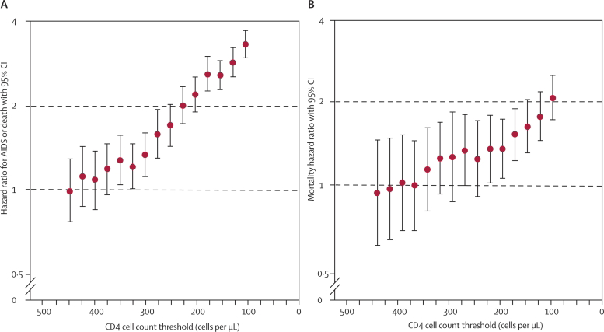

***Knowledge of HIV status increases uptake of prevention interventions making HIV testing essential to containing the HIV epidemic***

Prevention with positives is also a cornerstone of containing the epidemic in Africa9. Initiating treatment dramatically reduces the risk of transmitting HIV to sex partners, and even in the absence of treatment, learning one’s status has been shown to increase condom use and other preventive behaviors. HIV-discordant couples who undergo couple counseling and testing and become aware of their discordant status have reported >90% condom use in several studies in Africa, including trials conducted in Nairobi10,11. On the other hand, couples who do not test together and are in long-term stable partnerships assume that they share the same HIV status: if one tests positive the other assumes he/she is also positive, does not test, and does not take preventive measures or seek care. It is not surprising that the majority of transmission events occur when the HIV-infected partner is *not* aware ofhis/her status12, and that from the prevention standpoint, diagnosing and counseling the partners of newly infected persons can provide substantial benefits regardless of partner status.

***Partner notification services (PS) are a longstanding component of control programs for sexually transmitted infections (STI), including HIV***

In the United States and Europe, there is a long history of prevention of STI using partner notification strategies13, and there exists a small body of research that has investigated PS for curable STIs in developing countries14. The three most recognized modes of partner notification are 1) passive referral in which the person diagnosed with the STI (index case) is encouraged to disclose the results to his/her partners without direct involvement of a health care provider; 2) contract referral in which the index case is allowed a short period of time in which to contact and refer his/her sex partners, after which the provider notifies partners; and 3) provider referral in which the provider contacts sex partners directly, without a waiting period. For both the contract referral and provider referral, health providers obtain consent from the person diagnosed with an STI to interview them about their sexual partners and then locate these partners to inform them about the STI exposure *without revealing the identity of the index case*. The primary goals of the case-finding are to ensure that reported partners are notified, tested and successfully referred for medical care. The same principles apply for provision of PS for HIV with the addition that HIV-infected partners are potentially receiving life-saving treatment and preventing future transmission. The first randomized clinical trial of HIV PS was conducted in North Carolina ~20 years ago15 and HIV PS has since been incorporated into CDC guidelines and adopted by many US public health programs16,17. The role of partner notification services outside the US, and specifically in regions with a significant burden of disease due to HIV/AIDS, is promising but remains to be defined.

***Provision of partner notification services has been successful in Cameroon and Malawi***

While PS programs have not been widely instituted in Africa, there is growing evidence that they are effective, highly acceptable, and do not result in an increase in social harm18,19. In Cameroon and Malawi, the sites of 2 published studies, the HIV epidemic is generalized and many newly diagnosed persons identify stable, long-term partners who can be readily traced and tested. As a result, PS programs have been highly successful at case-finding. In the recently conducted randomized controlled trial in Malawi, the provision of PS involved health care providers notifying and testing sex partners with the consent of the index case2. This was found to increase by 2-fold the number of partners of HIV-infected persons who underwent testing compared to simply advising newly diagnosed persons to notify their partners themselves (Figure 4). In Cameroon, on ongoing PS program has now provided these services to over 4,000 persons, and more than one-third of persons receiving PS through the program are found to have a partner who was newly diagnosed with HIV infection. Furthermore, 25% of PS recipients are determined to be in long-term HIV discordant partnerships and this was not previously known to them. These data highlight the importance of PS as an HIV testing strategy and suggest that provision of PS in Africa works and can be scaled up to achieve high levels of coverage. This provides the rationale for implementing a PS program in Kenya that can be monitored closely and scaled up if found to be a good investment in resources from the public health perspective.

**Figure 4. Cumulative proportion of partners of newly HIV-infected individuals in Malawi presenting for testing by referral method *(Brown et al., JAIDS 2011******2******)***



***Intimate partner violence in African partner notification studies and PS programs is uncommon***

While there are many positive aspects of partner services, there are also potential negative ramifications. One concern is that intimate partner violence (IPV) will result from partner notification and place women at unnecessary risk. In the US, studies have suggested that partner notification does not increase partnership dissolution, however, if there is abuse in the relationship it may worsen with partner notification20,21. In sub-Saharan Africa, a number of studies have explored IPV in the setting of HIV and partner notification, and some report similar results. A Nairobi antenatal study found that although violence against women after partner notification was rare, with only 0.9% of women reporting post-test violence, IPV was more common among HIV-infected women and among those with a history of IPV22. A review article of more than 71 articles evaluating the relationship between IPV and HIV confirmed the presence of shared risk factors for IPV and sexually transmitted diseases, including HIV23, however, studies specifically examining whether couple counseling or partner notification results in an increase in IPV have not shown a causal relationship22,24, in part because of the challenges posed by conducting such studies. Given that the high prevalence of lifetime intimate partner violence in East Africa and other regions hard hit by the HIV epidemic25, introduction of a partner services program warrants close monitoring for IPV, as we are proposing in this study.

**Summary**

There is growing consensus that early recognition of HIV infection provides considerable individual and public health benefits. Early ART results in a more robust immunologic response to treatment, improved overall survival, and substantial reductions in risk of HIV transmission to sexual partners. Despite clear benefits and widespread promotion of HIV testing, many people living with HIV in Kenya and other regions in sub-Saharan Africa do not know that they are HIV infected. According to the 2007 Kenyan AIDS Indicator Survey, approximately 60% of HIV-infected people surveyed who thought they knew their status believed they were HIV negative6, and only 290,000 (21%) of the 1.4 million persons requiring ARV treatment in 2009 were receiving it1. Defining feasible and cost-effective ways to increase the identification of HIV-infected individuals is critical to national efforts to improve the health of persons living with HIV and contain the HIV epidemic. In the US, HIV case-finding through partner notification services (PS) is a central component of many public health HIV prevention efforts17. PS refer to public health efforts designed to ensure that the sex partners of persons with a sexually transmitted infection, including HIV, are tested and, if positive, referred for medical care. However, until recently, there were virtually no data to justify the implementation of large-scale public health PS. In the last year, that has change. Observational and clinical trial data from Cameroon and Malawi have recently demonstrated that assisted PS (aPS), a form of PS also known as *provider referral*, is effective, highly acceptable, and does not result in increased risk of intimate partner violence18,19. These data provide strong justification for more wide-spread implementation of PS programs, but also raise new questions related to the scalability of aPS in diverse settings, its cost-effectiveness, the population-level impact of aPS and how to measure it, and the need to test additional partners outside of index cases’ long-term relationships.

### List of abbreviations and acronyms

AE adverse event

AIDS acquired immunodeficiency syndrome

ARV antiretroviral

ART antiretroviral therapy

CBCHS Cameroon Baptist Convention Health Services

CDC Centers for Disease Control and Prevention

EIA enzyme immunoassay

ELISA enzyme linked immunosorbent assay

HC health centre

HIV human immunodeficiency virus

IRB institutional review board

KNH Kenyatta National Hospital

NASCOP National AIDS and STI Control Programme

SAE serious adverse event

STI sexually transmitted infection

UNAIDS Joint United Nations Programme on HIV/AIDS

UON University of Nairobi

US United States of America

USAID United States Agency for International Development

UW University of Washington

VCT voluntary testing and counseling

WHO World Health Organization

# NOTES

**NOTES**

**NOTES**